Climate Change in Korea and Algal Bloom Monitoring

- Introduction
Analyzing the 20th century temperature data observed in Korea shows that the average temperature has risen by 1.5 ℃, exceeding the global warming trend. The average precipitation during the 20th century fluctuated so much respectively and tends to increase in the long term.
Korea, which belongs to the Monsoon climate zone, has about 70% of the annual rainfall in summer, but the torrential rainfall in summer is increasing due to the effects of climate change.
The increase of the torrential rainfall raises the runoff of non-point pollutants, thereby promoting the eutrophication of the lake. And also the increase of temperature due to temperature rise causes algal blooms in the stagnant waters and seriously affects water quality of the drinking water resource.
In order to control the algal blooms, it is necessary to understand the concentration and distribution of the water quality parameters. Since the water quality of the wide-area water system such as Daecheong reservoir varies in time and place, it requires a lot of personnel and costs to observe the distribution and movement of pollutants by point sampling method. In this study, the distribution of chlorophyll-a and pollutants was analyzed by using satellite imagery(KOMPSAT-3) with the consideration of satellite transit time. Daecheong reservoir is the largest drinking water resource in the central South Korea, and the study area is the most severe algal bloom problem area in Daecheong reservoir.
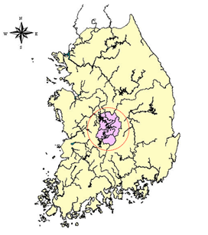
Figure 1. Study area

- Methodology
In this study, the concentration of chlorophyll-a was analyzed by sampling when KOMPSAT-3 satellite passes through the study area.
The optimal band and correlation between satellite image and chlorophyll-a concentration would be identified with the analysis of chlorophyll-a concentration.
And the regression analysis was performed using chlorophyll-a as a dependent variable and the reflectance of bands as independent variable.
After applying a regression model to the satellite image, the concentration of each pixel was calculated and pixels were divided by the concentration. The distribution of chlorophyll-a was mapping based on this procedure. The sampling point is shown in 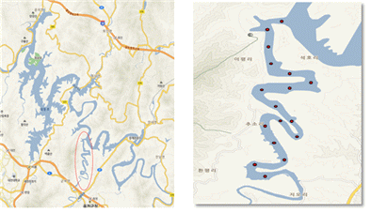Figure 2, and the detailed procedure is shown in Figure 3.
Figure 2. Daecheong reservoir and sampling sites.
Figure 3. Detailed procedure
Taking KOMSAT-3 Images, Chl-a Analysis
Geometric Correction
Radiometric Correction
Analysis of correlationship,
Development of Chl-a regression model
Masking File
Distribution of Chl-a Mapping

- Results
The KOMPSAT-3 images used in this study were taken on October 16, 2016 and May 11, 2017. When the satellite passed through the study area, samples were taken and analyzed for Chlorophyll-a. After pretreatment of satellite images, the correlation between chlorophyll-a and bands was analyzed between reflectance converted from DN(Digital Number) value and chlorophyll-a. The reason for converting the DN value to reflectance is that if the date taken by the satellite is different, the DN value should be converted to the same physical dimension so that the satellite image data can be standardized. After the correlation analysis, a band with high correlation with chlorophyll-a was selected and a regression model was derived from chlorophyll-a as dependent variable and band-specific reflectance as independent variable.
The reflectance was increased in most bands when chlorophyll-a concentration increased. A regression model was derived with using the 2nd band(green) as reflectance wavelength of the chlorophyll, 3rd band(red) as absorption wavelength and 4th band as near infrared wavelength closely related to the number of algae particles. A regression model with R² of 0.71 was obtained as follows.

Chl-a = 1779.96*BA2-1029.99*BA3-16.66*BA4+78.88 (R²=0.71)
BA : band

The concentration at each pixel was calculated by the applying the satellite images at each time point. The distribution of the chlorophyll-a was obtained by dividing the ranges according to the concentration.
In order to create a distribution map, making a masking file was required to distinguishes between land and water. A regression model was applied to the masking file to create a chlorophyll-a distribution.

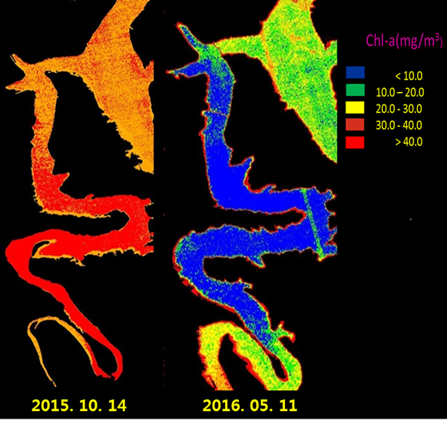
Figure 4. Chlorophyll-a distribution maps

- Conclusion
A regression model was developed using KOMPSAT-3 satellite image and chlorophyll-a concentration when passing through the satellite. The spatial distribution of chlorophyll-a could be mapping by applying the model to the study area. The image data has very useful functions to understand the overall chlorophyll-a concentration of the wide-area and to detect a large concentration change. If continuous data accumulation is made in the future, it will be possible to manage the three-dimensional water quality.

Reference
Allan, M.G., Hamilton, D.P., Hicks, B.J. & Brabyn, L., Landsat remote sensing of chlorophyll a concentrations in central North Island lakes of New Zealand. International Journal of Remote Sensing, 32(7), 2037-2055, 2011.
Jun Chen, Zhenhe Wen, Zhengqing Xiao, Spectral Geometric Triangle Properties of Chlorophyll-A Inversion in Taihu Lake Based on TM Data, Journal of Water Resource and Protection, 3, 67~75, 2011.
H. T. Duan, Y. Zhang, B. Zhang, K. Song, Z. Wang, “Assessment of chlorophyll-a concentration and trophic state for Lake Chagan using Landsat TM and field spectral data”, Environmental Monitoring and Assessment, Volume 129, Issue 1-3 , pp 295-308, 2007.
Allan, M.G., Hamilton, D.P., Hicks, B.J. & Brabyn, L., Landsat remote sensing of chlorophyll a concentrations in central North Island lakes of New Zealand. International Journal of Remote Sensing, 32(7), 2037-2055, 2011.

